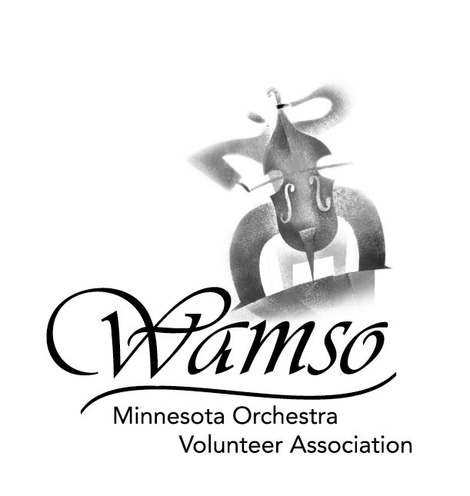
2006 WAMSO YOUNG ARTIST COMPETITION

AFFIDAVIT CONCERNING EDITING RULES
FOR COMPETITION COMPACT DISCS/TAPES

PLEASE RETURN AFFIDAVIT WITH
APPLICANT’S PERFORMANCE CD/TAPE
POSTMARKED ON OR BEFORE OCTOBER 10, 2005
(International entries must be postmarked
on or before October 3, 2005.)

I, ________________________________________, certify that I have read the rules for the WAMSO Young Artist Competition (YAC) and that by submitting this entry, I agree to be bound by them in their entirety. I understand that I will be disqualified if the YAC determines that I have broken the rules, including if it is discovered that I have submitted a CD or tape that has been edited. I agree to accept the decision of the YAC regarding editing and compliance with other rules as final, not only for my entry, but also for the entries of all other competitors.

Signature of Applicant: _________________________________________ Date: ____________________

Name of person/studio who made this recording: __________________________________________

Address: ______________________________________________________________________________

I, ___________________________________ (person/studio representative) certify that I (this studio) did not edit this CD/tape as per the YAC rules which govern this competition.

Signature of Person/Studio Representative: _________________________________ Date: ___________

I, _________________________________________ (applicant’s teacher or qualified professional) certify that to the best of my knowledge, the CD/tape accompanying this application has not been edited and complies with the rules put forth by the YAC regarding this competition. I understand that my student’s application will be disqualified if it is determined that he/she has broken the rules, and I agree to accept the YAC’s decision as final for all entries.

Signature of Applicant’s Teacher (or qualified professional: ______________________________________

Phone number: ___________________________________ Date: _____________________

