1111 Nicollet Mall ▪ Minneapolis MN 55403-2477 ▪ 612-371-5654 ▪ wamso@mnorch.org
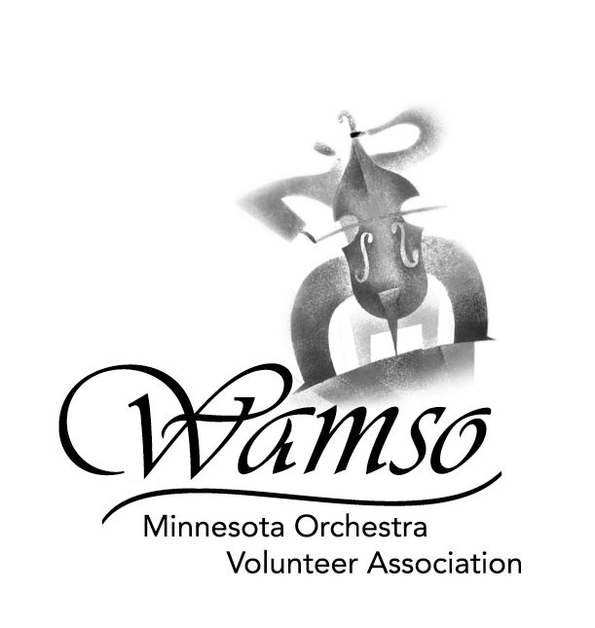

Dear Contestant:

Thank you for your interest in the 2006 WAMSO Young Artist Competition. This packet contains all of the forms and instructions necessary to apply and compete in the preliminary round of the competition. Please review all materials carefully. All preliminary judging is done by CD or tape only. You will be notified by e-mail or telephone by the end of November if you have advanced to the semi-final round.

The semi-final competition will be held on Saturday, January 14, 2006, at Macalester College in Saint Paul, Minnesota. The finals will be held on Sunday, January 15, 2006, at Orchestra Hall in Minneapolis, Minnesota.

When you return the completed application, please use the following checklist:

→ Your application will not be accepted unless all the following items have been included
APPLICATION CHECKLIST –
Application must be postmarked on or before September 12, 2005.
International entries must be postmarked on or before September 5, 2005.
- Application Form
Be sure to include signature of certifying teacher or representative of organization,
your instrument and your signature
- Repertoire Form
- Summer Study Form
- Check payable to WAMSO in the amount of $75 US (non-refundable)

PERFORMANCE CD/TAPE CHECKLIST –
CD/tape must be postmarked on or before October 10, 2005.
International entries must be postmarked on or before October 3, 2005.
 CD/tape
Label outside of CD/tape case with your name and your instrument
 Affidavit Form

NOTE: No names on CD/tape itself. Preliminary CD/tape will NOT be returned.

If you have questions or wish more information, please address inquiries to WAMSO at the address at the top of this letter, call Annette Conklin at 651-450-1607 or e-mail wamso@mnorch.org.

Sincerely,

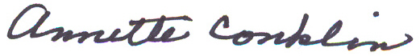

Annette Conklin
Young Artist Competition Co-chair
651-450-1607; annetteconklin@earthlink.net

