2006 WAMSO YOUNG ARTIST COMPETITION
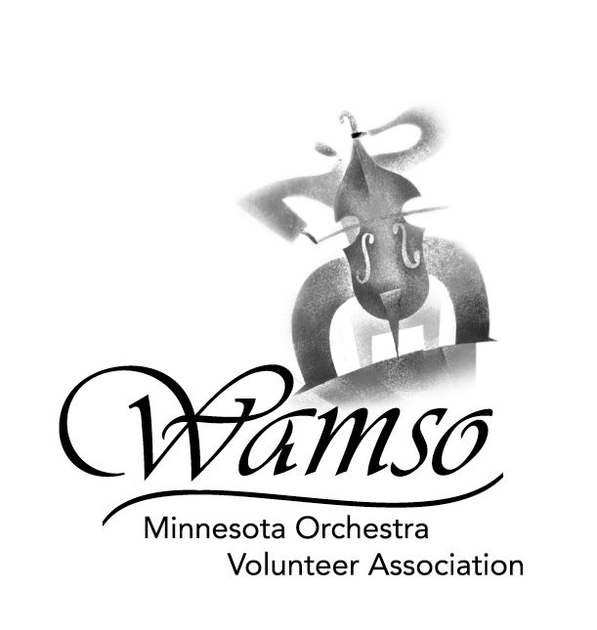
MAJOR PRIZES, PERFORMANCE OPPORTUNITIES
& SUMMER STUDY

MAJOR PRIZES

GRAND PRIZE (Awarded to First Prize winner at the discretion of the Minnesota Orchestra Music Director or Designate)
- Performance with the Minnesota Orchestra at a subscription concert under the direction of the Music Director
- $1,000 award from the Minnesota Orchestra in memory of Isaac Stern for his dedication to young artists

FIRST PRIZE
- $5,000 WAMSO Young Artist Award
- $2,500 WAMSO Achievement Award
- Performance with the Minnesota Orchestra
- Taped performance on McGraw Hill's Young Artist Showcase, WQXR, New York

SECOND PRIZE
- $2,500 WAMSO Award
- Taped performance on McGraw Hill's Young Artist Showcase, WQXR, New York

THIRD PRIZE
- $1,000 WAMSO Award

OTHER AWARDS:
- ELAINE LOUISE LAGERSTROM MEMORIAL AWARD - $1,000 Violin Award
- MATHILDA HECK AWARD - $1,000 Woodwind Award
- TWIN CITIES MUSICIANS UNION AFM AWARD - $1,000 Award
- VINCENT R. BASTIEN MEMORIAL AWARD - $500 Cello Award
- MARY WINSTON SMAIL MEMORIAL AWARD - $500 Piano Award

PERFORMANCE OPPORTUNITIES

SAINT PAUL CIVIC SYMPHONY - Concerto performance

THE SCHUBERT CLUB OF SAINT PAUL - Recital performance

SUMMER STUDY

ASPEN MUSIC SCHOOL, Aspen, Colorado
Sponsored by WAMSO and the Aspen Music School. The award covers tuition, room and board for the full 2005 nine-week session

MADELINE ISLAND MUSIC CAMP, La Pointe, Wisconsin
Sponsored by WAMSO and Madeline Island Music Camp, for violin, viola, cello and piano. The award covers tuition, room and board for four weeks

INTERLOCHEN CENTER FOR THE ARTS, Interlochen, Michigan
Sponsored by WAMSO and Interlochen Center, offered to the highest-ranking high school contestant

