2006 WAMSO YOUNG ARTIST COMPETITION
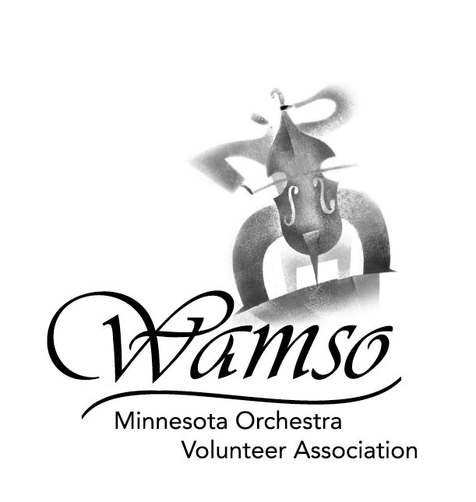
REPERTOIRE FORM
(Must be returned with Application Form by entry deadline)

Name _____________________________________________________________________________
Last First Middle

Telephone ____________________________________ Instrument _____________________________

PRELIMINARY AND SEMI-FINAL ROUNDS - You must be prepared to play all pieces in their entirety in the semi-final and final rounds. The Concerto must be performed from memory.

Concerto: _____________________________________________ ___________________________
Composition (FULL TITLE) Composer

❑ Single movement work  Multi-movement work (list title or tempo marking of each movement
and approximate playing time of each, e.g. allegro, ca. 5’) Playing Time

- ____________________________________________________ __________
- ____________________________________________________ __________
- ____________________________________________________ __________
- ____________________________________________________ __________
Estimated total playing time: __________

Solo work #1: _________________________________________ ___________________________
Composition (FULL TITLE) Composer

❑ Single movement work  Multi-movement work (list title or tempo marking of each movement
and approximate playing time of each, e.g. allegro, ca. 5’) Playing Time

- ____________________________________________________ __________
See Repertoire Requirements
for detailed explanation
- ____________________________________________________ __________
- ____________________________________________________ __________
- ____________________________________________________ __________
Estimated total playing time: __________

Solo work #2: ________________________________________ ___________________________
Composition (FULL TITLE) Composer

❑ Single movement work  Multi-movement work (list title or tempo marking of each movement
and approximate playing time of each, e.g. allegro, ca. 5’) Playing Time

- ____________________________________________________ __________
- ____________________________________________________ __________
- ____________________________________________________ __________
- ____________________________________________________ __________
Estimated total playing time: __________

FINAL ROUND - You must offer the same concerto plus one of the two additional solo works.

Please check or circle the solo work you will play in the final round: Solo Work #1  Solo Work #2 

Questions regarding repertoire should be directed to Lola May Thompson at 651-698-7177 or 218-575-2813

(summer residence), or to Annette Conklin at 651-450-1607 or annetteconklin@earthlink.net.

