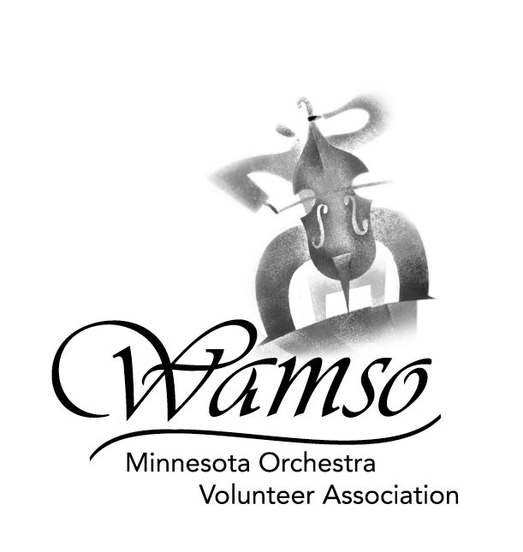
2006 WAMSO YOUNG ARTIST COMPETITION
REPERTOIRE REQUIREMENTS

Preliminary and Semi-final Rounds

- Contestants must prepare an entire concerto or major concert piece with orchestra from the standard repertoire for their instrument. Memorization for this work is required through all rounds of the competition. Questions regarding repertoire should be directed to Lola May Thompson at 651-698-7177 or 218-575-2813 (summer residence), or to Annette Conklin at
651-450-1607 or annetteconklin@earthlink.net. WAMSO recommends that you clarify all
repertoire questions before submitting your application.

- Contestants must also offer two additional solo works of their own choosing that are of contrasting styles and periods and are from the standard repertoire. Unaccompanied solo works are permitted. Extracted movements of multi-movement pieces are not allowed, e.g. the contestant may offer a full sonata, but not just selected movements of a sonata. Memorization of these two works is not required, except for pianists.

To help you select the two pieces of your own choosing, use the following guidelines:
- A substantial work from the Baroque period
- A major multi-movement work from the Classical period
- A substantial work from the Romantic Era (shorter works of not less than ten minutes in length may be chosen if they display both technical and musical demands)
- A substantial work from the 20th century
- Percussionists' repertoire selections must include at least two of the following three instrument categories: marimba, timpani, multiple percussion.

- Please note (as stated in the instructions for preparing your CD/tape) that you are required to choose sections of the two additional solo works for your preliminary round recording and are not required to record these pieces in their entirety. However, if you advance to the semi-finals you must be prepared to play all pieces in their entirety, as the judges will select the specific portions they wish to hear.

Final Round

- Each contestant shall offer the same concerto that was played in the previous rounds. Memorization is required.

- Contestants shall also offer one of the two additional solo works that was offered in the previous rounds. Memorization for this additional work is not required, except for pianists. You are required to select this piece when you submit your application; changes will not be allowed at a later date.

Application with Entry Fee, Repertoire Form and Summer Program Scholarship Form must be postmarked on or before September 12, 2005.
(International entries must be postmarked by September 5, 2005.)

