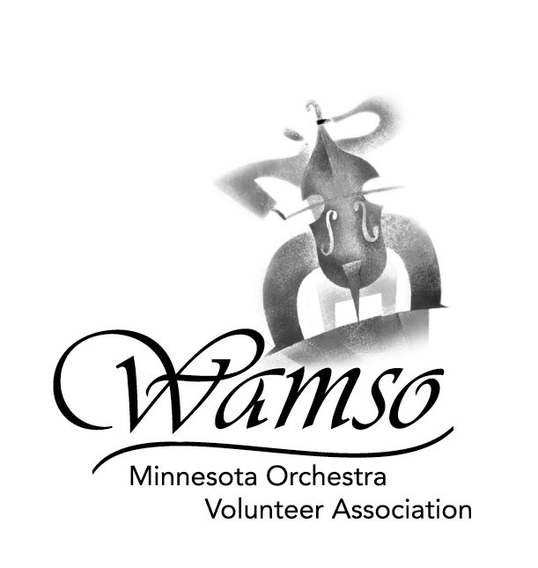

2006 WAMSO YOUNG ARTIST COMPETITION
January 14 and 15, 2006

RULES AND INSTRUCTIONS FOR APPLICATION

Please read carefully before completing the application materials.

- ELIGIBILITY: Contestants must be performers of instruments that have permanent chairs in the Minnesota Orchestra. Contestants must also be residents of or students in:
Illinois Kansas Missouri South Dakota
Indiana Michigan Nebraska Wisconsin
Iowa Minnesota North Dakota Manitoba or Ontario

2. AGE: Contestants must not have reached their 26th birthday as of January 15, 2006.

- ENTRY FEE: A non-refundable fee of $75 US is due at the time of application.

- REPERTOIRE: Contestants must prepare a concerto or significant concert piece with orchestra from the standard repertoire, plus two additional contrasting solo works of their own choosing. (See Repertoire Requirements for a detailed explanation.)
- ACCOMPANISTS: CDs/tapes submitted for the preliminary round must include piano accompaniment. The only exceptions are unaccompanied solo works and piano concertos – the second piano part of the piano concerto should not be included on the CD/tape but is required in the semi-final and final rounds. Contestants who reach the semi-finals will arrange for their own accompanist. If needed, WAMSO will provide a list of local pianists.
- CERTIFICATION: An application will not be considered complete unless signed by the student's current teacher or a representative of the certifying organization.

- APPLICATION DEADLINE: Mail your application to WAMSO, 1111 Nicollet Mall, Minneapolis, MN 55403-2477 postmarked on or before September 12, 2005. (International entries must be postmarked on or before September 5, 2005.) There are no exceptions. Your application will not be accepted unless all required information and fees have been included.

- CD/TAPE DEADLINE: Send your unedited CD/tape to WAMSO, 1111 Nicollet Mall, Minneapolis, MN 55403-2477 postmarked on or before October 10, 2005. (International entries must be postmarked on or before October 3, 2005.) There are no exceptions.

- PERFORMANCE OPPORTUNITIES: The Minnesota Orchestral Association and WAMSO work together to provide the winner with performance opportunities within eighteen months of the competition. The winner is expected to make every attempt to be available for the performance offered.

- TAPED RADIO PERFORMANCE: Tape is to be prepared according to specifications and subject to acceptance by WQXR-AM and WQXR-FM, New York City.

- CANCELLATION OF COMPETITION: WAMSO reserves the right to postpone or cancel the competition if the standard of the competition cannot be maintained due to circumstances beyond its control.
QUESTIONS? Please contact Annette Conklin at 651-450-1607
or e-mail annetteconklin@earthlink.net.

