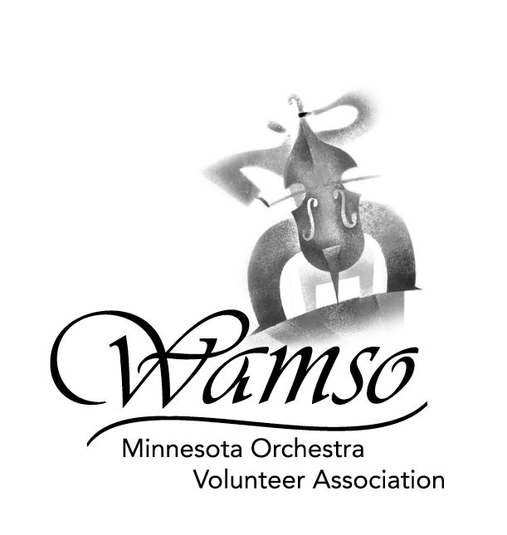
2006 WAMSO YOUNG ARTIST COMPETITION
SUMMER STUDY FORM

PLEASE RETURN WITH APPLICATION FORM
POSTMARKED BY SEPTEMBER 12, 2005
(International postmark date: September 5, 2005)

NAME ____________________________ INSTRUMENT ______________ AGE_____

I would like to be considered for:

Aspen Music School, Aspen, Colorado YES___ NO ___
Madeline Island Music Camp, La Pointe, Wisconsin YES___ NO ___
Interlochen Center for the Arts, Interlochen, Michigan YES___ NO ___
(The Interlochen award is for high school students only.)

I give permission for WAMSO to notify the awards representatives
of my interest in their programs. YES ___ NO ___

Winners of awards for summer study opportunities will be announced at the presentation ceremony on Sunday, January 15, 2006, following the finals at Orchestra Hall.

MUSICAL RESUME

Write briefly about your musical training, teachers and the number of years spent in musical study. Also list the names of awards and contests you have won. You may attach a résumé if you wish.

